**FGPA Guide**

**Step #1:** Click the Synthesize button in Xilinx ISE. (This will take several minutes)

**Step #2:** Click the Implement Design button in Xilinx ISE. (This will take several minutes)

**Step #3:** Click the Generate Programming File button in Xilinx ISE. (This will take several minutes)

**Step #4:** Plug in FPGA via USB.

**Step #5:** Under “Configure Target Device”, click the Manage Configuration Project (IMPACT) button. The ISE iMPACT tool window will now open.

**Step #6:** Run the wizard by clicking Edit\Launch Wizard. The “Welcome to iMPACT” window will open.

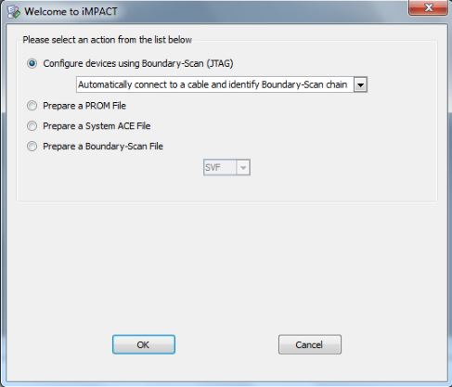

Click OK.

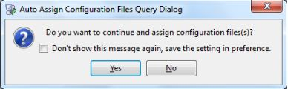

Click Yes.

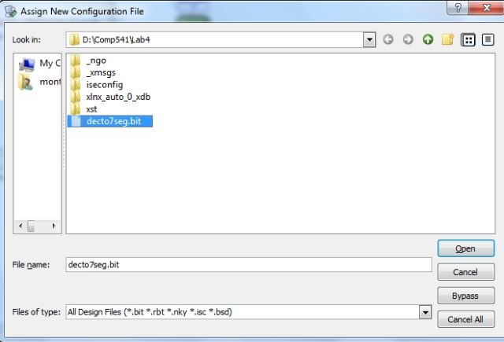

Select the .bit file that you generated in Step 3.

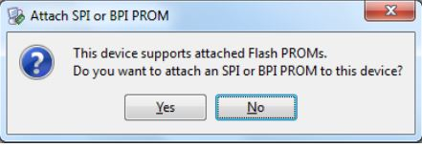

Select No.

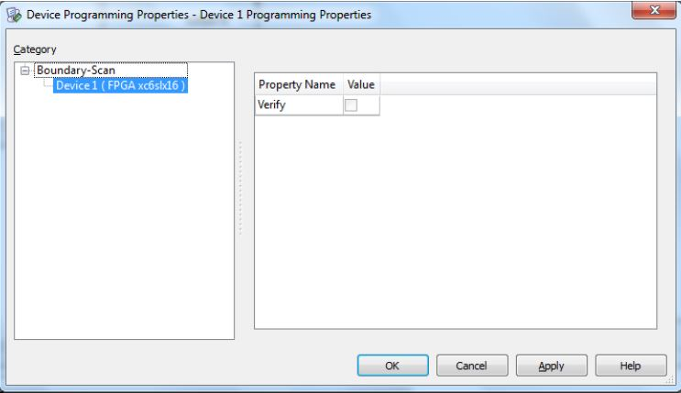

Click OK.

**Step #7:** If there are no errors, you will see an “Identify Succeeded” message. Right-click on the green Xilinx box and click program.

**Step #8:** Look at the port mappings in rtl_description.xlsx and configure test setup.